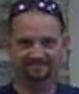  Deacon  Rob Kogut  Secretary Candy Kogut  Treasurer Carmella Patrone  Church Leader Richard Baugh  Church Leader Eldon Lingg  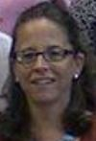  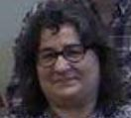  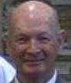   |  |  | Living Truth Deaf Church  Welcomes  You to  2017 Fall Revival  ‘It is Not About Me’  On Saturday, October 28th  @ Light House Baptist Church  Lally Fellowhip Hall  9:00 a.m. to 4:00 p.m.  By James Campbell  Nursery provided  Children’s Ministry
Motto Statements

- As Baptist believers grounded by our faith in Jesus Christ, we unite as a church to honor God through Worship and Bible Study, to be trained in Christian Discipleship, and to share in Christ’s love through witness, fellowship and service.

- We believe that the Bible is the Word of God, that Jesus Christ is the Son of God, that He died and rose from the
dead, that He is coming again, and that salvation is only through personal faith in Jesus and God's amazing grace.

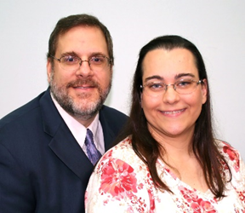  James and Joy Campbell  James was raised in a Catholic family and attended church but he was lost. He received the infant baptism, first communion and sacrament confirmation but that didn’t give him the inner peace. He worked 50-80 hours weekly in the Catholic church’s ministries in hope to find the inner peace. After two years of volunteering, he decided that it was time to go to the college. Two deaf men met him in his dormitory hallway and showed him the way to find the inner peace. On November 1995, at age of 27 years old he received Christ as Savior. As a new creature in Christ, his heart is greatly burdened for lost souls. In June 1997, he married Joy who also shared his burden for the lost souls. At the summer of 1997, he started to study the pastoral studies and received the Bachelor of Arts degree. | He taught many various courses at the Capitol Bible Deaf College and was an associate pastor at Hampshire View Baptist Deaf Church in Silver Spring, MD for 12 years. Currently he is a deaf pastor, leading the deaf ministry at Grace Bible Baptist Church in Baltimore, MD and is an international missionary with International Partnership Ministries in Hanover PA, traveling all over the world. It is his burden to train the foreign nationals to reach the deaf with the emphasis the need of Deaf leaders whose primary language was their native sign language rather than interpreters in a hearing church.  Lunch will be provided:  Subs (variety)  Soup (Chicken rice)  Chips  Water & Iced Tea  Assorted desserts  Schedule:  9:00 to 9:30 a.m.: Welcome  9:30 to 11:00 a.m.: 1st service  11:00 to 1:00 p.m.: Lunch  1:00 to 3:00 p.m.: 2nd service  3:00 to 4:00 p.m.: Closing fellowship | Living Truth Deaf Church  Time of worship  Sundays:  Sunday School  9:15 a.m. to 10:15 a.m.  Sunday Service  10:30 a.m. to 12:00 p.m.  Wednesdays  Bible Study  6:30 p.m. to 8:00 p.m.  Contact Us  Living Truth Deaf Church  (at Lighthouse Baptist Church)  1842 Otts Chapel Road Newark, Delaware 19702  VP: 302.261.3138  Email: LTDChurch@gmail.com  Website: LTDC.LBCDE.org

